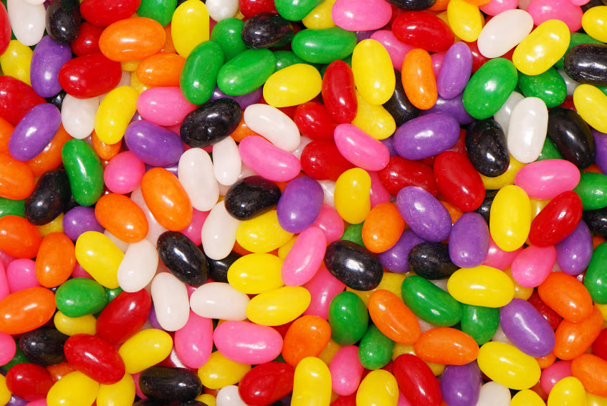

The Jelly Bean Gospel

Purple - Reminds us of the robe and crown that the Roman soldiers made Jesus wear. John 19:5

Red - Reminds us of the blood Jesus shed for our sins. Romans 5:8

Black - Reminds us of the dark tomb Jesus’ body was in for 3 days.  
1 Corinthians 15:3b-4

Pink - Reminds us of those who cried when Jesus died. John 20:13

Orange - Reminds us of the sunrise on Easter morning when Jesus rose to life. Matthew 28:1

White - Reminds us of the angel that rolled the stone away. Matthew 28:2-4

Green - Reminds us of the garden where Jesus prayed. Matthew 26:36-38

Yellow - Reminds us of eternal life with Jesus when we trust him as our Savior. John 3:16



The Jelly Bean Gospel

Purple - Reminds us of the robe and crown that the Roman soldiers made Jesus wear. John 19:5

Red - Reminds us of the blood Jesus shed for our sins. Romans 5:8

Black - Reminds us of the dark tomb Jesus’ body was in for 3 days.  
1 Corinthians 15:3b-4

Pink - Reminds us of those who cried when Jesus died. John 20:13

Orange - Reminds us of the sunrise on Easter morning when Jesus rose to life. Matthew 28:1

White - Reminds us of the angel that rolled the stone away. Matthew 28:2-4

Green - Reminds us of the garden where Jesus prayed. Matthew 26:36-38

Yellow - Reminds us of eternal life with Jesus when we trust him as our Savior. John 3:16